# Homework 4

## Part A

### Problem 1

#### Q1

#### Q2

|  |  |  |
| --- | --- | --- |
| N | vecadd00 time (s) | vecadd01 time (s) |
| 500 | 0.000196 | 0.000182 |
| 1000 | 0.000325 | 0.000296 |
| 2000 | 0.000717 | 0.000694 |

### Problem 2

#### Q3

#### Q4

|  |  |  |
| --- | --- | --- |
| size | matmult00 time (s) | matmult01 time (s) |
| 256 | 0.029247 | 0.117618 |
| 512 | 0.233194 | 0.938891 |
| 1024 | 1.863072 | 7.011287 |

## Part B

#### Q1

#### Q2

#### Q3

#### Q4

|  |  |  |  |  |  |  |  |
| --- | --- | --- | --- | --- | --- | --- | --- |
| Array length | CPU | Without Unified Memory | | | With unified memory | | |
| One block with one thread | One block with 256 threads | Multiple blocks with 256 threads per block | One block with one thread | One block with 256 threads | Multiple blocks with 256 threads per block |
| 1000000 | 0.000529051 | 0.0498991 | 0.00169992 | 1.40667e-05 | 0.0497382 | 0.00184202 | 1.5974e-05 |
| 5000000 | 0.00327206 | 0.340272 | 0.0111539 | 5.72205e-05 | 0.329387 | 0.0115008 | 5.88894e-05 |
| 10000000 | 0.00799704 | 0.675524 | 0.023195 | 0.000102043 | 0.657916 | 0.0235169 | 9.98974e-05 |
| 50000000 | 0.0464098 | 3.2892 | 0.115762 | 0.000462055 | 3.29497 | 0.116319 | 0.000455141 |
| 100000000 | 0.092972 | 6.75364 | 0.232134 | 0.000912905 | 6.59013 | 0.232395 | 0.000904083 |

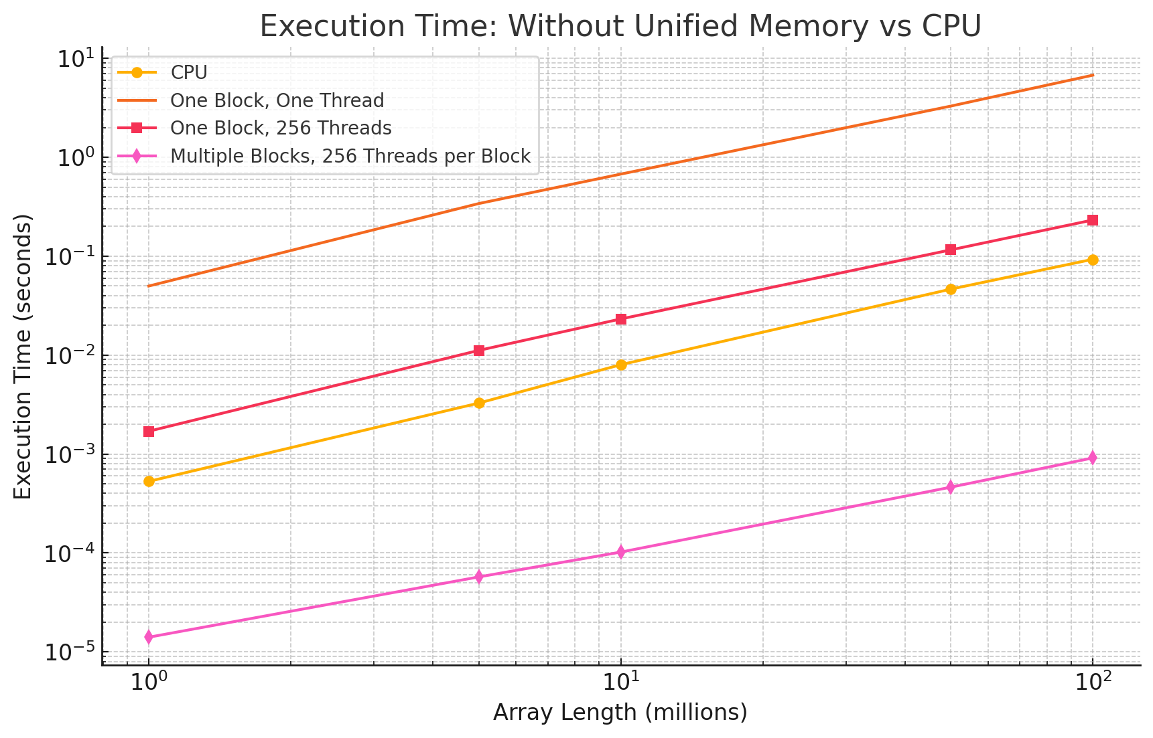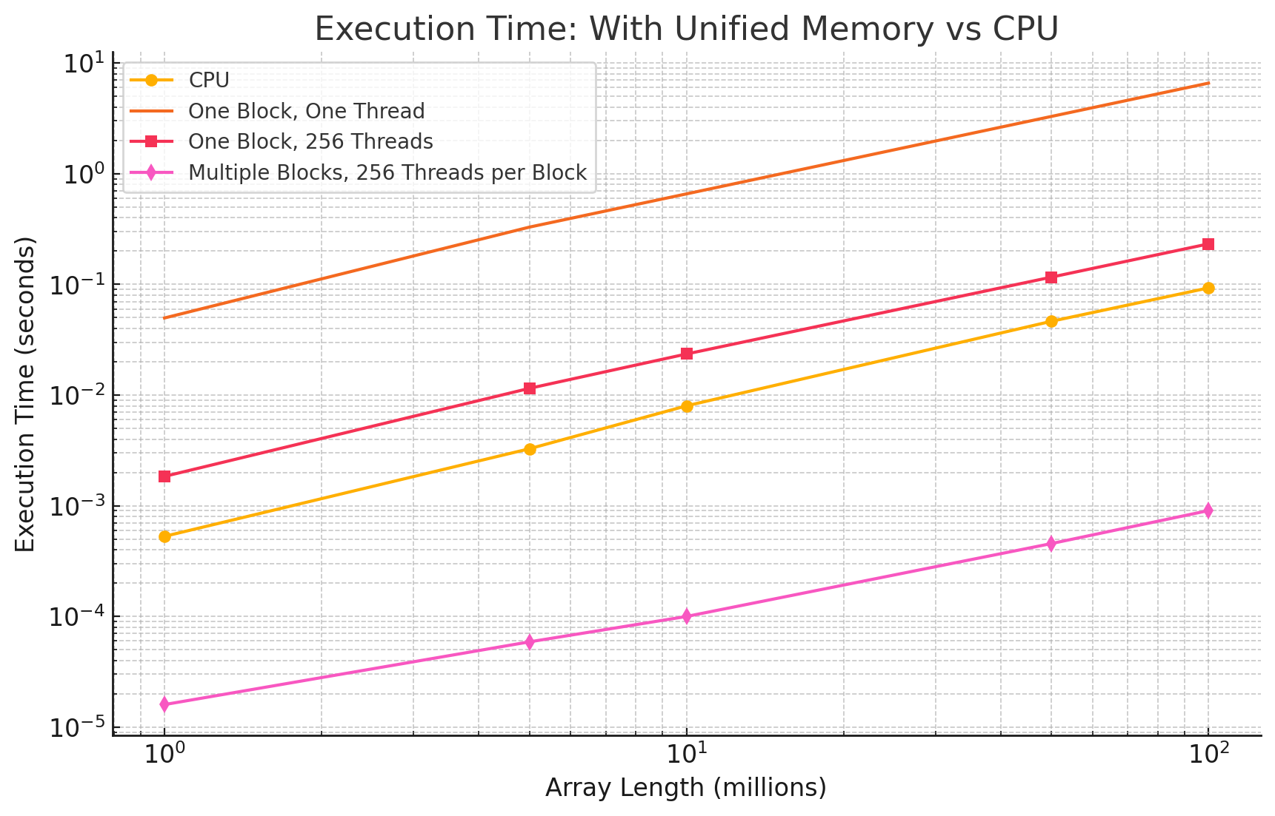

## Part C

### C1

### C2

### C3

122756344698240.000000, 2.517

110975745783360.000000, 2.039

0.000000, 147.151